- Consider the graph of the shown below.
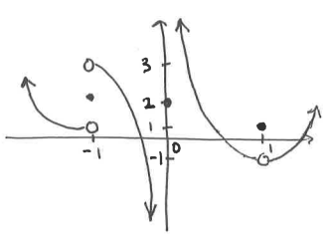

Determine each of the following.

- Create a function that has the following properties.

- Answer each of the following questions.
- Create a function that has the following properties.

- Can you draw another function that meets all of the given conditions but has different behavior at the x-values of -2, 1, & 3?

- Consider the function .
- Graph .
- Determine each of the following limits.

